Name ___________________________ Marketing I

**Liebs Tips for Role Play**

Important Reminders:

* Show a VISUAL
* CONFIDENCE is KEY to a successful role play
* Talk clearly
* Don’t talk too fast
* Be aware of your nervous tendencies – Playing with your hair, fidgeting with your hands, etc.
* It is okay to GLANCE down at your paper

Important Performance Indicator Terms:

* Core value of product/service – What is this product/service about? What is their main goal? What do they value the most?
* Clientele – The clients or customers you have currently have or are wanting to get.
  + Ex: It is important to keep my current CLIENTELE happy.
* Buying Behavior - Purchase decision based on certain aspects: what factors will influence/influenced the buyer to make this purchase?
  + Ex: trendy, healthy, specific benefit, loyalty, etc.
  + Why will consumers make this specific purchase?
* Current Business Trends – What is currently trendy in the business world? Specifically, relate it to your role play.

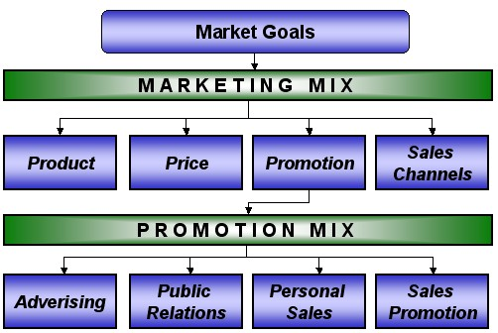

**Promotional Mix**

1. Advertising - mass media content intended to persuade audiences of readers, viewers or listeners to take action on products, services and ideas. The idea is to drive consumer behavior in a particular way in regard to a product, service or concept.

2. Public Relations - involves the planned promotion of goods, services and images of organizations intended to create goodwill for a person, place or event.

* What are you doing to get the word out about your product/service/client?

3. Personal Sales – Making a sale on your product/service. You can have a sales team, sales force.

4. Sales Promotion - Is used to introduce new product, clear out inventories, attract traffic, and to lift sales temporarily. It is more closely associated with the marketing of products than of services.

* The chief tools of sales promotion are discounts ("sales"), distribution of samples and coupons, the holding of sweepstakes and contests, special store displays, and offering premiums and rebates.

Product Mix - Refers to the total number of product lines that a company offers to its customers.

* Ex: Pepsi Co. – Soda, Chips, Quaker Oats, Gatorade

Selling Function – Selling is a prominent business process whereby salespeople interact directly with your company's buyers and try to persuade them that the benefits offered by your solution are a good value for the money.

Distribution Channel:

* Manufacturers, Wholesalers, Retailers.

Positive Customer Relations – Having a POSITIVE relationship with your customers. Why?

* Brings them back, loyalty, will tell others about your product/service, etc.

**Product Life Cycle**

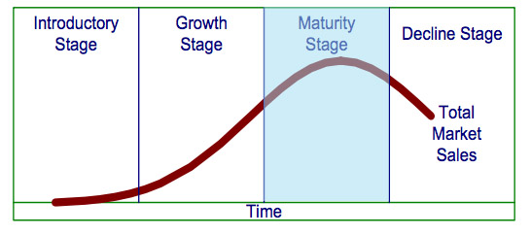

**Links for Performance Indicators by Category.**

**Please print your corresponding category on your own time. This is a VERY helpful guide

and specific to each category.**

Apparel & Accessories - <http://www.tvdsb.ca/files/86513/piapparelandacccessoeies.pdf>

Automotive Services Marketing - <http://www.tvdsb.ca/files/86514/piautomotiveservices.pdf>

Business Services - <http://www.tvdsb.ca/files/86516/pibusinessservices.pdf>

Food Marketing - <http://www.tvdsb.ca/files/86515/pifoodmarketing.pdf>

Hotel & Lodging Management - <http://www.tvdsb.ca/files/86517/pihotelandlodging.pdf>

Marketing Management - <http://www.tvdsb.ca/files/86518/pimarketingmanagement.pdf>

Quick Serve Restaurant - <http://www.tvdsb.ca/files/86519/piquickserve.pdf>

Restaurant & Food Service Management - <http://www.tvdsb.ca/files/86520/pirestaurantandfoodservice.pdf>

Retail Merchandising - <http://www.tvdsb.ca/files/89900/piretailmerchandising.pdf>

Sports & Entertainment Marketing - <http://www.tvdsb.ca/files/86550/pisportsandentertainment000.pdf>

Hospitality & Tourism (Principals also) - <http://www.tvdsb.ca/files/86542/pihospitalityservices.pdf>

Principals of Marketing - <http://www.tvdsb.ca/files/86544/pimarketingmanagement.pdf>

Business Law & Ethics - <http://www.tvdsb.ca/files/86546/pibusinesslawandethics.pdf>

Hospitality Services - <http://www.tvdsb.ca/files/86548/pihospitalityservices.pdf>

Travel & Tourism - <http://www.tvdsb.ca/files/86551/pitravvelandtourism.pdf>